- \Operation\Basic settings\Reference offset values
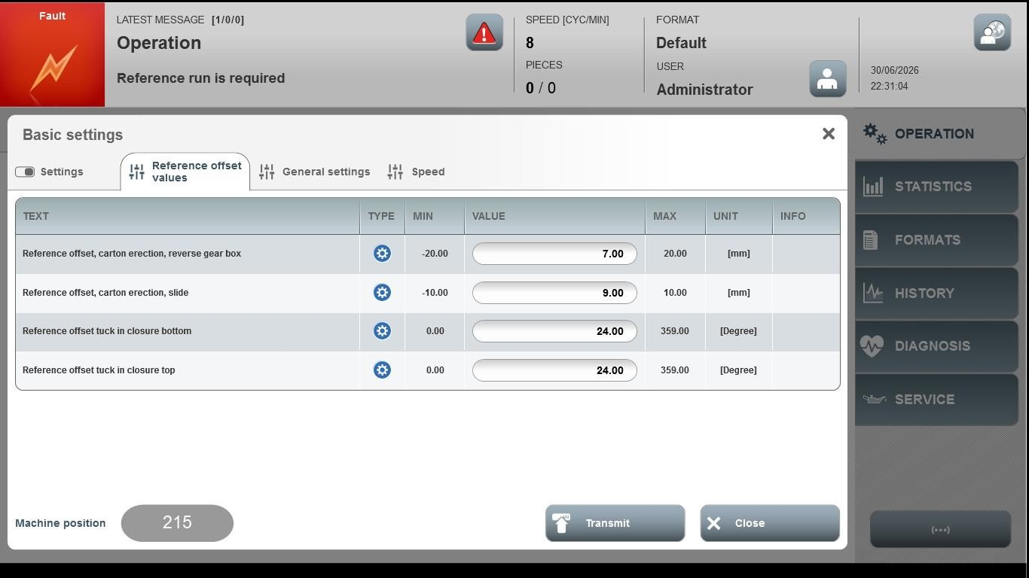
Acceptance criterion | Limits | Pass / Fail: Dev-No. | Date | Initials
Screen matches screenshot | N / A
Reference offset, carton erection, reverse gear box | -20.00 ... 20.00
Reference offset, carton election slider | -10.00 … 10.00
Reference offset truck in closure bottom | 0.00 … 359.00
Reference offset truck in closure top | 0.00 … 359.00

